

EXP_NO_1(a)

EXP_NO_1(b)



EXP_NO_1(c)



EXP_no_1(d)

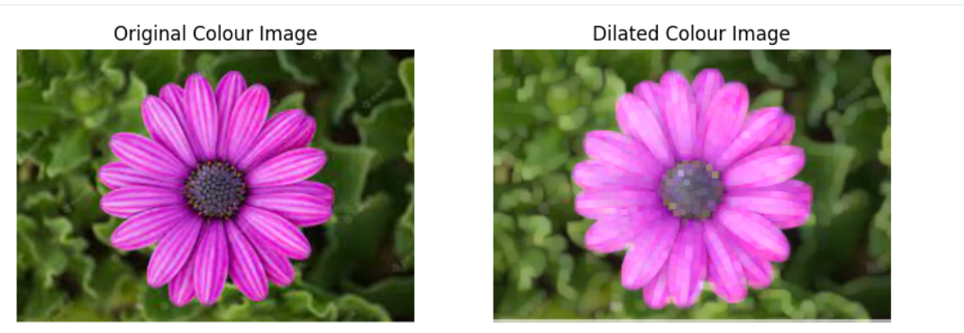

EXP_no_1(e)





EXP_no_4

EXP_no_5

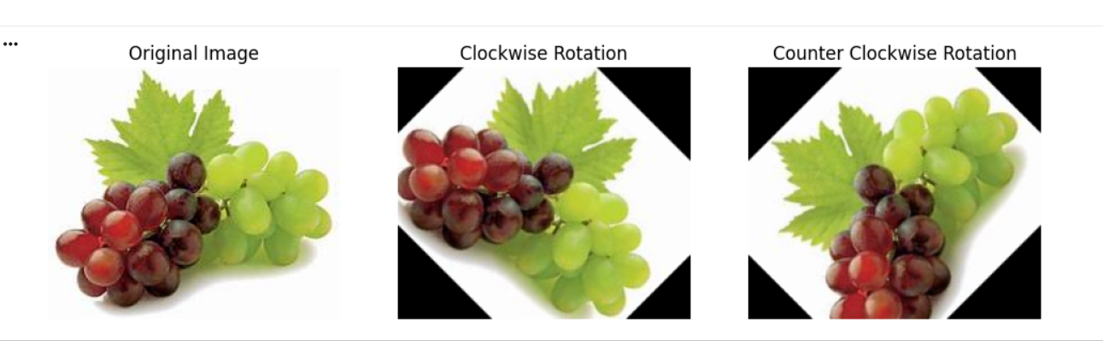



EXP_No_6

EXP_no_7





EXP_NO_8

EXP_NO_10



EXP_NO_11

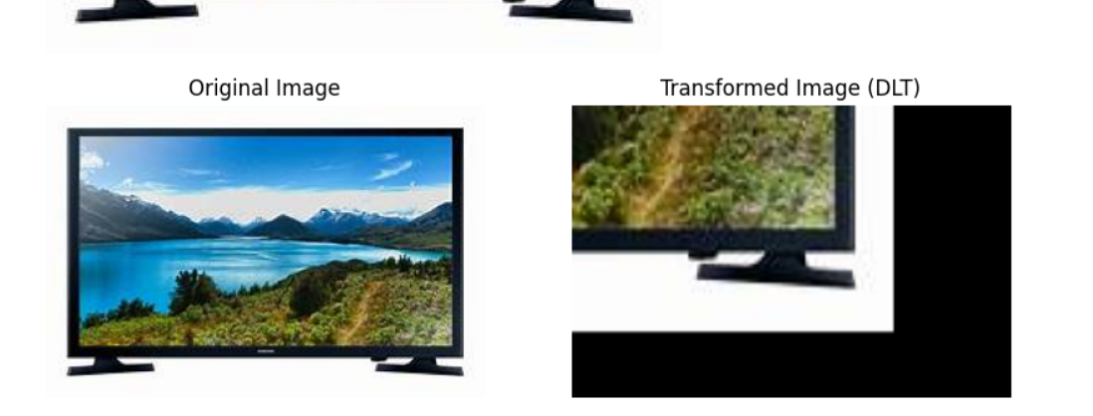



EXP_no_12

EXP_NO_13



EXP_NO_14



EXP_NO_15



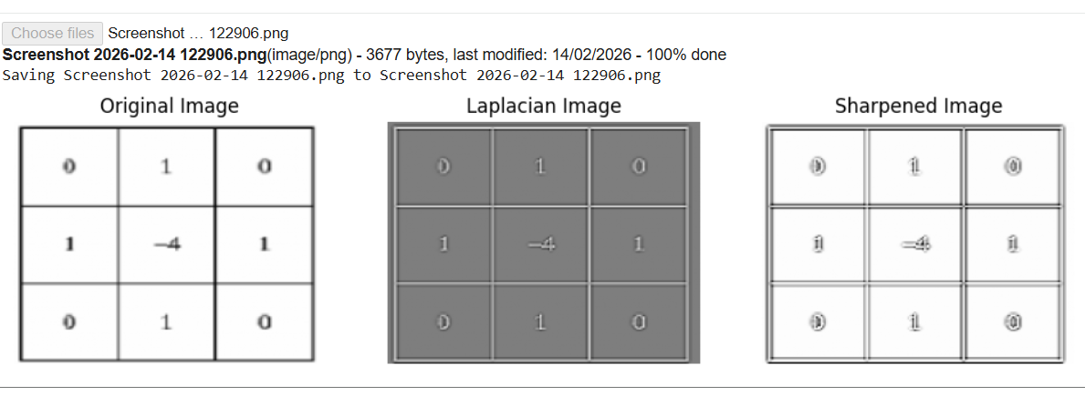

EXP_no_16

EXP_NO_17

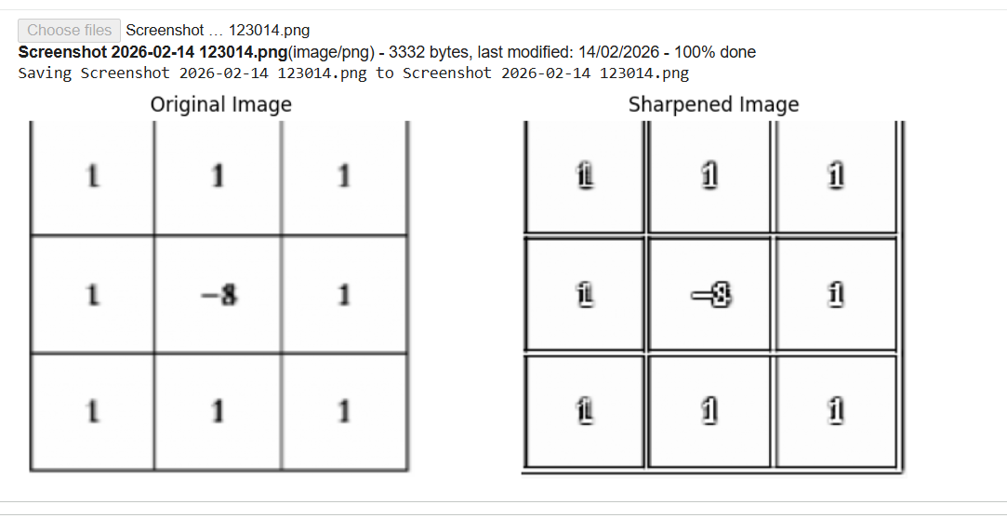

EXP_no_18

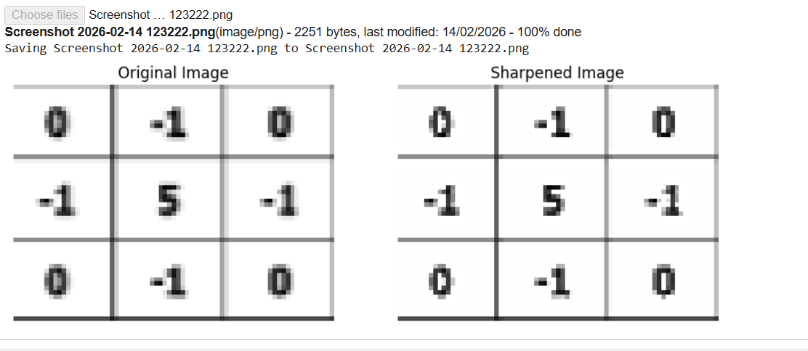

EXP_NO_19

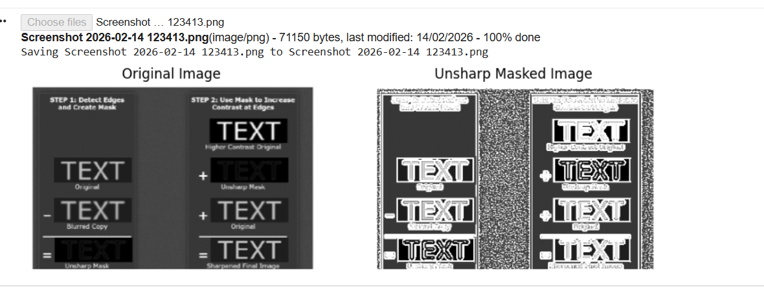

EXP_NO_20

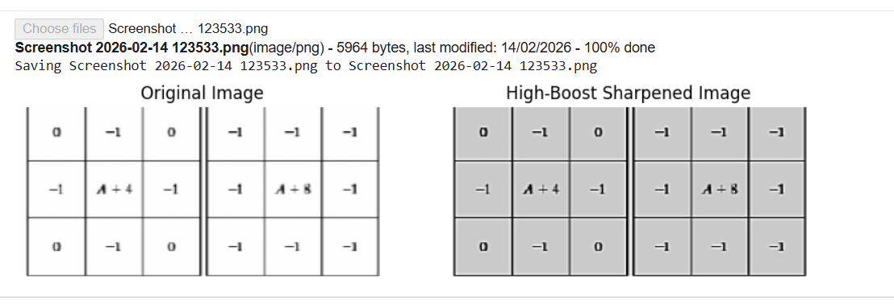

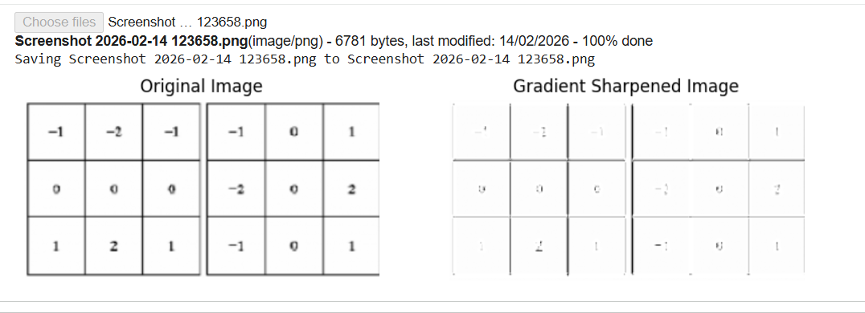

EXP_NO_21



EXP_NO_22



EXP_no_22

EXP_NO_23

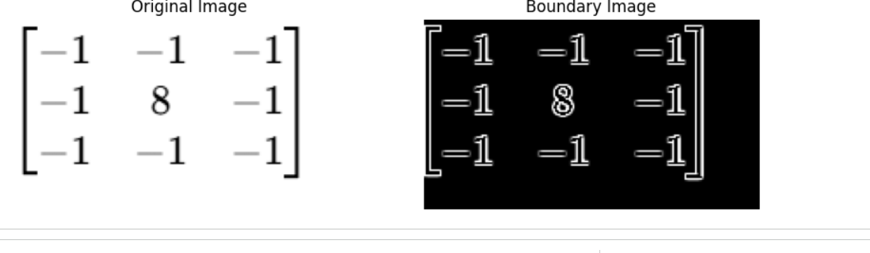

EXP_NO_24



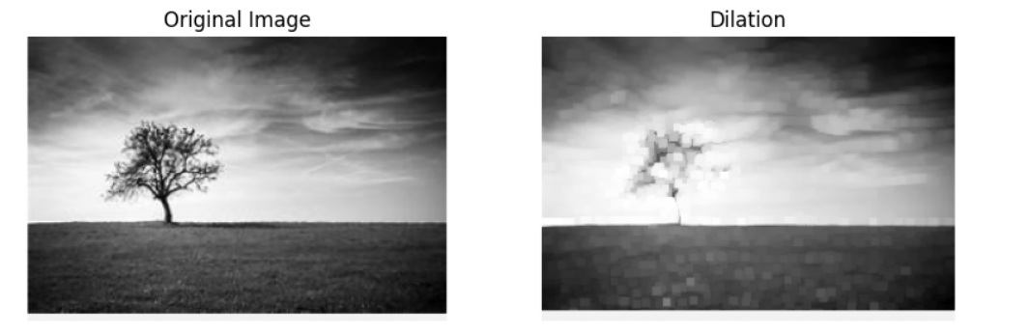

EXP_NO_25

EXP_NO_26

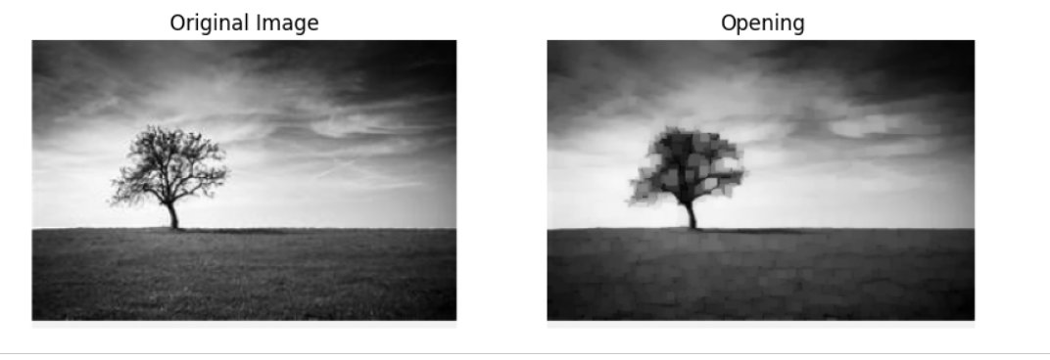

EXP_NO_27



EXP_NO_28

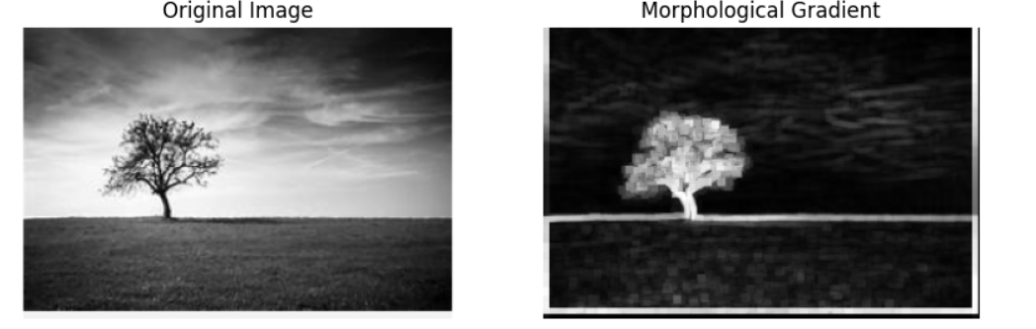

Exp_no_29



Exp_no_30

